**Is it the last hurdle, or just the insistence in despair?**

Contact us:

ibsghk@gmail.com

**——****WM Motor IPO review**

Abstract:

Once centered the financing arena among Chinese New Forces, WM Motor made yet another move to IPO. However, its performance and misses in expectations left grounds for doubt if the recent effort revealed WM's despair of its tight cash flow.

* We foresee hurdles for WM’s competitiveness in high-end market and a decrease of its shares in mid to low end market
* From cost’s angle, we analyze price dynamics of raw and intermediate materials for automotive batteries
* Two questions are explored:
  + Will new energy vehicles at low and medium prices survive, and how should WM break out?
  + Why is WM's IPO financing a move to tide over the difficult times due to business pressure?

Content:

Abstract: 1

1. Transaction Overview 3

2. Transaction Highlight: Financial 4

a. Revenue 4

b. Expense 7

3. Review of Key Questions 9

a. Will new energy vehicles at low and medium prices survive, and how should WM break out? 9

b. Is the IPO a go for broke or a way to get through a current difficulty? 10

# 1. Transaction Overview

WM Motor Holdings Limited is an innovative electric vehicle manufacturer that provides autonomous driving solutions, named from the German world champion (Weltmeister). Established in 2015, WM has the No. 1 electric SUV sales figure in 2019 and 2020. The EX5 SUV, in the mainstream market in China, whose retail price is around RMB160,000. The EX5 model has a spacious interior and is equipped with advanced technologies such as Living Pilot AD/ADAS, Living Engine smart cockpit, and Living Motion electric powertrain, which young Chinese families would favor.

The market is never a blue ocean. WM Motor, NIO, XPeng, Li Auto, and other 'New Forces' started simultaneously. When other EV "New Forces" and new energy vehicle companies began to deliver and entered a critical period of rapid development, WM Motor fell into a bottleneck. From 2019 to 2021, Weimar's deliveries were 12,799, 21,937, and 44,152 respectively. Since September 2018, the total delivery was 83,495. This figure is less than half that of the Tier 1 OEMs, not even the GOAT among the Tier 2 OEMs.

Financing is a recurring theme for WM Motor. Since its establishment, WM Motor has financed at least once a year on average. The 10 billion RMB C+ round in September 2021 set a record for the most significant single round of financing in the history of "New Forces". Before the listing, WM Motor's accumulated financing amounted to about 35 billion RMB, the largest pre-IPO financing amount among Chinese EV "New Forces".

However, WM still suffers from liquidity issues due to its negative bottom line. According to its prospectus, WM Motor's cash and cash equivalents were only 4.16 billion RMB, as of December 31, 2021. This cash balance is far lower than the 40-50 billion RMB reserve of NIO, XPEV, LI, and even lags behind Leap's 4.338 billion RMB. This is inseparable from its gross loss of less than -40% for three years. If the gross margin is not improved, its cash will be quickly exhausted.

# 2. Transaction Highlight: Financial

Even though having net loss generally happens in the industry, the loss of WM seems significant in the industry. In the reporting period, the WM has the gross loss rate of -41.1%, -43.5%, and -58.3%, far from profiting. The NEV companies generally have lower gross margins compared to other sectors in the supply chain, and WM is one of the companies below the average performance.

Table 1 Comparable Companies

|  |  |  |  |  |  |
| --- | --- | --- | --- | --- | --- |
| No. | Name | EV Revenue Share (2021) | Gross Margin for EV | | |
| 2021 | 2020 | 2019 |
| 1 | NIO | 96.74% | 20.56% | 16.36% | 0.50% |
| 2 | XPEV | 95.49% | 12.50% | 3.54% | NA |
| 3 | BYD | 52.04% | 17.39% | 25.20% | 21.88% |
| 4 | DongFeng | 88.50% | 3.60% | 13.24% | 13.20% |
| 5 | BAIC | 57.31% | -32.73% | -55.64% | 11.51% |
| 6 | Geely | 99.60% | 17.14% | -2.48% | 3.52% |
| 7 | JAC | 84.05% | 6.46% | 0.00% | 0.00% |
| 8 | Chana | 94.39% | 15.45% | 13.65% | 12.39% |
| 9 | Leap | 97.66% | -44.30% | -50.63% | -95.73% |
| 10 | WM | 90.65% | -41.10% | -43.50% | -58.30% |
| Aver. | | | -2.50% | -8.03% | -10.11% |

Among comparable companies, Leap has the gross lost rate similar to WM, which also has submitted its prospectus to HKEX. To understand whether these NEV companies are experiencing their last hurdle to profit, or just insisting in despair, we dig deeper into the topline and COGS of WM to understand its profitability.

## a. Revenue

The current product lineup of WM consists of SUVs and sedans (Figure1), with SUVs including the EX5, EX6, and W6, and sedans including the E5/E5Pro and the M7 (to be released in the second half of 2022）. Among the delivered models, the EX5 and E5 are priced between RMB 160,000 and RMB 200,000, while the EX6 (279,000 RMB) and W6 (259,800 RMB) are priced at a higher level, but are still some distance away from breaking through RMB 300,000. The M7 model with up to 32 sensors to be released in the second half of 2022 is considered likely to break through RMB300,000.

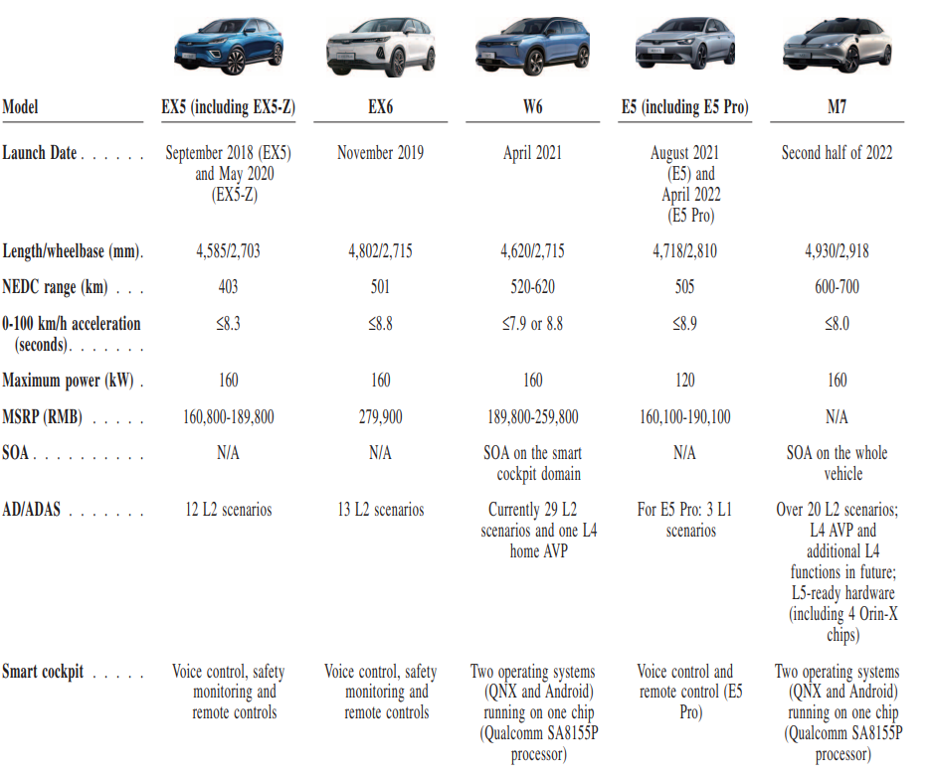

1 Product Lineup

In the first half of 2022, the WM's most sold model is E5 (including E5 Pro), followed by W6 and EX5. EX5's sales dropped by 80% YoY due to the "power lock" and "spontaneous combustion" problems. The EX6, which is currently the most expensive WM model in the market, sold only 6 units from January to July 2022, which makes people worried about the upcoming high-end model M7 of WM. However, EX6's weakness in the market is largely due to its early launch time and did not make the latest update. The competitiveness of the car is even far less than W6 in the same brand. If the M7 can be lowered to a minimum price of about RMB 250,000, it could be very competitive in the current market.

Although all of WM's models are priced above RMB 160,000, its prospectus shows that its main business' revenue/total car sales in 2021 is RMB 107,000, much lower than WM's marked price of RMB 160,000. The large gap is due to the 10% purchase tax, 13% VAT (Value-added-Tax), and the commission to its distributers. The average price of the leading new energy brand NIO is around RMB 360,000, also below the guided price of most of its models.

Considering the underperformance of the highest price model EX6, WM is less likely to insist entering the more competitive market of higher price vehicles. Subsequently, the two factors which lifts the selling price are the transmission of upstream cost change and change in commission to the retailer, which is the gap between after-tax selling price and the average revenue of each vehicle sold. In early 2022, downstream manufacture like WM reacted actively to the upstream cost dynamics due to the commodities price. With this mechanism, we can offset the transmission of upstream price change in the future calculation.

Table 2 Gap in revenue and marked price

|  |  |
| --- | --- |
| Marked Price | 160,000 |
| **Tax\*** | 23% |
| **After Tax Price** | 123200 |
| **Average Revenue** | 107000 |
| **Spread** | 16200 |

*Tax including both 10% of purchases tax and 13% of VAT

From history, we found that the commission to the distributer for each car is lowered when the volume of the sale is lifted. In the case distributer still get higher total commission as the increase in volume has a more significant impact on their earnings. We expect the spread between after-tax marked price to be fraped into 80%, 70% and 65% in the following 3 years, considering the stage of the market promotion.

Table 3

|  |  |  |  |  |
| --- | --- | --- | --- | --- |
|  | 2021 | 2022E | 2023E | 2024E |
| After Tax Price | 123200 | 123200±△ | 123200±△ | 123200±△ |
| Spread % | 100% | 80% | 70% | 65% |
| Spread | 16200 | 12960 | 11340 | 10530 |
| Average Revenue | 107000 | 110240±△ | 111860±△ | 112670±△ |

*△ is the transmission of upstream cost change

## b. Expense

In the 2020 and 2021, the material purchased composed about 80% of the COGS, which is expected to increase due to the positive scale effect in the foreseeable future. The most expensive component of NEV is battery and motor.

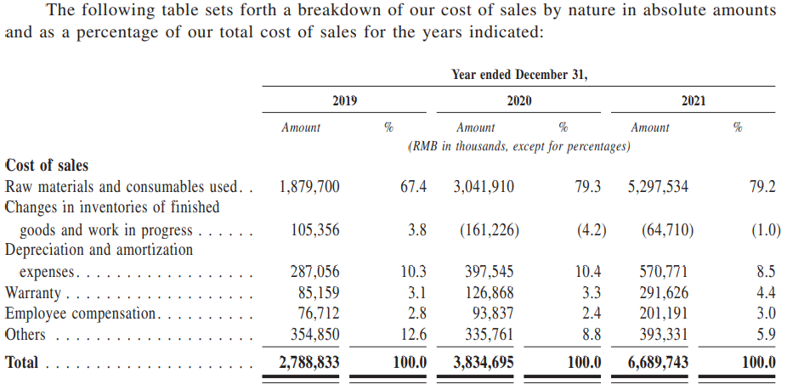

2 WM's Selling expense

Due to the strong demand for new energy vehicles and energy storage, the raw material side of the new energy battery has been in short supply. CCA data shows that in the first half of 2022, domestic production and sales of new energy vehicles were 2.7 million units and 2.6 million units, a YoY increase of 1.2x. In the first half of this year, the cumulative installed capacity of China's power batteries was 110.1 GWh, with an YoY increase of 109.8% .Among them, ternary battery installed volume accounted for 41.4%, an increase of 51.2%; LFP battery installed volume accounted for 58.5%, an increase of 189.7%.

From the above data, we can see that the power battery installed are mainly ternary battery and LFP battery, no matter in which of the two, the cost of cathode material occupies a dominant position. Ternary battery cathode mainly has nickel, cobalt, and lithium three elements composition. The current ternary battery is mainly high-nickel ternary battery, with nickel in the highest proportion of the three elements. Unfortunately, the production of nickel in China is not large, and global nickel sulfide is mainly distributed in South Africa, Canada, Russia, and other countries; laterite nickel is distributed in Indonesia and Australia, both of which can be used as raw materials for a ternary cathode. As the demand side continues to pull up together with the impact of the epidemic, some regions have not been able to restore production capacity, which caused the price rise of nickel. Although the overall upward trend of a short time cannot change, the price increase will be relatively stable and lead the future price of nickel more optimistic in the next six months. The other two elements of ternary battery lithium, cobalt lithium carbonate and cobalt sulfate raw materials, have increased significantly. LFP battery cathode material lithium iron phosphate prices have soared in the past year, with a YoY increase of 183.11%, and the future form is not optimistic.

Compared with lithium batteries, the raw material for motors, permanent magnet material, is very stable, with no significant increase in the past year, and should also maintain a stable trend in the future. To sum up, the change in raw materials cost cannot be easily estimated, but we can have it canceled out with the mechanism mentioned in the Revenue section.

Another driver is the change in interval cost distributed on each vehicle influenced by the scale effect, which can be represented by increase of the cost proportion of the raw materials. Using the public information of the comparable companies in the respective scales, we expect the cost proportion of following 3 years to be 83%, 85% and 88%.

|  |  |  |  |  |
| --- | --- | --- | --- | --- |
|  | 2,021 | 2022E | 2023E | 2024E |
| After Tax Price | 123,200.00 | 123200±△ | 123200±△ | 123200±△ |
| Spread% | 100% | 80% | 70% | 65% |
| Spread | 16,200.00 | 12,960.00 | 11,340.00 | 10,530.00 |
| **Average Revenue** | **107,000.00** | **110,240.00**±△ | **111,860.00**±△ | **112,670.00**±△ |
| Average Cost of Raw Materials | 120000* | 120000±△ | 120000±△ | 120000±△ |
| Cost Proportion of Raw Materials | 79% | 83% | 85% | 88% |
| **Average COGS** | **151,515.15** | **144,578.31**±△ | **141,176.47**±△ | **136,363.64**±△ |
| **Average Gross Income** | **-44,515.15** | **-34,338.31** | **-29,316.47** | **-23,693.64** |

*△ is the transmission of upstream cost change

As forecasted with the assumptions, WM cannot reach a positive gross profit by the end of the 2024.

# 3. Review of Key Questions

## a. Will new energy vehicles at low and medium prices survive, and how should WM break out?

According to China's new energy passenger car sales data, the sales volume of China's new energy passenger car will reach 3.312 million units in 2021, with a market penetration rate of 15.7%, and an increase of nearly 10% compared to the 5.8% penetration rate in 2020, showing an explosive growth trend. In terms of sales structure, the new energy passenger car market in 2021 shows a "dumbbell" sales structure, with A00-class and B-class battery electric vehicle (BEV) making the largest contribution to annual new energy vehicle sales. According to the data from related associations, in 2021, the cumulative sales of A00-class BEV will be about 898,500 units, accounting for 30.1% of the BEV market; the cumulative sales of B-class BEV will be about 616,000 units, accounting for 20.6% of the market.

This situation is mainly because the new energy vehicle market is still in its early stage, and the current sales volume mainly relies on star products. Among the A00-class BEV, the representative model is Wuling Hongguang Mini EV; while the B-class vehicles are represented by BYD Han, Tesla Model 3. Although the price difference is huge, they both have one thing in common - the first to be generally recognized by the public in this relatively unfamiliar segment. The rapid growth in sales of A00-class BEV has made more consumers recognize and accept new energy vehicles, while B-class and above BEV have fully demonstrated to consumers the huge potential of new energy vehicles and their infinite possibilities. The significance of these two types of vehicles for the promotion of new energy vehicles is undeniable. However, with the maturing of the domestic new energy vehicle market and the trend of auto consumption upgrades, the volume of the A00-class BEV market will stabilize, and the growth rate will slow down after 2022. With the entry and development of more forces such as Internet, technology and entity manufacturing enterprises, the development of new energy vehicles will become more diversified and intelligent, and the cost of high-end intelligent electric vehicles would also decline. In this way, the sales structure of the maturing new energy vehicle market will return to the "spindle shape", and the middle of the "spindle shape" is the low and middle price range of RMB 150,000-250,000. Since the low and mid-range models of 150,000-250,000 can both meet the R&D and hardware investment threshold of intelligent electric vehicles and closely follow the practical needs of most consumers for "cars".

In the current market environment, if WM wants to stand out from various brands, we think the most important point is to improve their product competitiveness and build trust with customers, so as to obtain a good reputation. Li Auto focuses on space and practicality, NIO focuses on the high-end and the new mode of power exchange, XPeng focuses on intelligence and design, and NETA focuses on its cost-effectiveness. As for WM, the only feature we can identify from it is the team with rich experience in building cars from traditional car companies. Though the team's background made the first few rounds of financing smooth sailing, as there was never any doubt that WM couldn't build a real car, the same conservative flaws of traditional car companies are reflected in WM's products. The most sold EX5 of WM is only a mediocre level in terms of performance, design, and technology, not to mention the problems of "power lock" and "spontaneous combustion". The BEV market is already an extremely segmented market, occupying only 2% of the car market and it doesn't need to be segmented any further. The only way to get more market share is to improve the performance and reliability of its car so that consumers have enough reasons to choose WM to truly achieve the breakthrough.

## b. Is the IPO a go for broke or a way to get through a current difficulty?

From WM's current situation, the IPO in Hong Kong is both a go for broke and a necessary measure to tide over the difficult times.

**Why WM's IPO is a go for broke under market pressure?**

WM, which was established by Shen Hui, the former global vice president of Volvo, has always been loved by investors as a new force in car manufacturing that became famous early on, and this love is also directly reflected in the financing. After WM completed nearly $600 million pre-IPO financing in the first half of this year, WM's price-to-sales ratio was as high as 9.51x, significantly higher than the 5.94x, 6.81x, and 7.62x of other three Chinese new energy vehicle brands NIO, XPeng and Li Auto, which are currently listed. By now, WM has completed 12 rounds of financing totaling 35 billion RMB before going public, and its valuation has unprecedentedly exceeded $7 billion.

On the surface, the new round of financing of WM seems to be a great achievement, further enriching its cash flow while also successfully building momentum for the listing and boosting its valuation. Behind the brilliance, we can see that WM is fighting against the tide this time, completing the financing with the belief that it is a failure if it does not go public. We can see some signs of this from SAIL's announcement of this investment in WM.

3. WM's betting agreement

The SAIL's announcement regarding the WM Financing states that "subject to certain conditions set out in the outline and detail rules (including the failure of WM to complete the Qualifying IPO within a specified time after the closing of the Share Purchase Agreement) SAIL shall be entitled to a right of redemption." This paragraph clearly shows the existence of a betting agreement in SAIL's financing of WM. If WM fails to successfully complete the Hong Kong IPO, it will probably face a huge financial crisis.

**Why is WM's IPO financing a move to tide over the difficult times due to business pressure?**

Although we mentioned above that WM had just completed about $600 million in financing before filing its prospectus, raising a total of more than 35 billion RMB in 12 rounds, the level of money being burned to build the car still makes WM feel cash-strapped. According to the prospectus, WM's revenue in 2019, 2020 and 2021 will be 1.762 billion, 2.672 billion and 4.743 billion RMB respectively. WM's adjusted losses for the three years are 4.04 billion RMB, 4.225 billion RMB and 5.363 billion RMB respectively, a loss of more than 13 billion RMB in the past three years. financing 4.149 billion RMB, 5.63 billion RMB and 6.491 billion RMB from 2019 to 2021, respectively, with a three-year financing amount of 16.27 billion RMB, WM's books were only able to show 4.156 billion RMB of cash. In addition to financing, the increase in cash acquisition is also reflected in the company's borrowings. WM's borrowings in the last three years were RMB 2.42 billion, RMB 6.41 billion and RMB 10 billion respectively, which directly resulted in the net finance costs doubling directly from RMB 389 million in 2020 to RMB 784 million in 2021.

In addition, new energy vehicles industry is an industry that relies heavily on a company's ability to develop and innovate, and WM has also been branded as "technology" since its debut. However, according to the prospectus, WM's R&D investment in 2019, 2020 and 2021 will be $893 million, $992 million and $981 million, respectively, accounting for 50.7%, 37.1% and 20.7% of revenue in the same period. In other words, WM has reduced its spending on research and development while its revenue will grow significantly in 2021, and its three-year investment in research and development is declining as a percentage of revenue for the same period. For a company that relies so much on technology, reducing R&D spending would be extremely damaging to the company, and WM would not have been able to do so if not for financial constraints.

The above points show that WM's operation is currently in a very difficult stage and urgently needs a large amount of capital to replenish and give new impetus to the rusty wheels of WM.

WM's IPO financing is both a desperate attempt and a way to get through the difficult times, as WM is a veteran new energy vehicle powerhouse that has been late in completing its IPO. After the IPO of NXL (short for NIO, XPeng, and Li Auto), its downside position is becoming more and more obvious. The Hong Kong IPO will raise a lot of money and make WM and several new energy vehicles on the same platform again. At the same time, it can also compensate to a certain extent for the confidence of investors in WM after the failure of the IPO of the Shanghai Stock Exchange Science and Technology Innovation Board.